**ASSIGNMENT 2 FRONT SHEET**

|  |  |  |  |
| --- | --- | --- | --- |
| **Qualification** | **TEC Level 5 HND Diploma in Computing** | | |
| **Unit number and title** | **Unit 43: Internet of Things** | | |
| **Submission date** | December 25th, 2023 | **Date Received 1st submission** | December 25th, 2023 |
| **Re-submission Date** |  | **Date Received 2nd submission** |  |
| **Student Name** | LE NGUYEN NHUT KHOI | **Student ID** | GCC210092 |
| **Class** | GCC1001 | **Assessor name** | LUONG HOANG HUONG |
| **Student declaration**  I certify that the assignment submission is entirely my own work and I fully understand the consequences of plagiarism. I understand that making a false declaration is a form of malpractice. | | | |
|  |  | **Student’s signature** | LE NGUYEN NHUT KHOI |

**Grading grid**

|  |  |  |  |  |  |  |
| --- | --- | --- | --- | --- | --- | --- |
| P5 | P6 | P7 | M5 | M6 | D3 | D4 |
|  |  |  |  |  |  |  |

|  |  |  |
| --- | --- | --- |
| **❒ Summative Feedback: ❒ Resubmission Feedback:** | | |
| **Grade:** | **Assessor Signature:** | **Date:** |
| **Internal Verifier’s Comments:** | | |
| **Signature & Date:** | | |

# Assignment Brief 2 (RQF)

## Higher National Certificate/Diploma in Business

|  |  |
| --- | --- |
| **Student Name/ID Number:** |  |
| **Unit Number and Title:** | **Unit 43 – Internet of Things** |
| **Academic Year:** | **2021** |
| **Unit Assessor:** | **Tran Trong Minh** |
| **Assignment Title:** | **Assignment 2 – Internet of Things** |
| **Issue Date:** |  |
| **Submission Date:** |  |
| **Internal Verifier Name:** |  |
| **Date:** |  |

|  |
| --- |
| **Submission Format:** |
| *Format:* This assignment is an Individual assignment and specifically including 1 document:  You must use font *Calibri size 12, set number of the pages and use multiple line spacing at 1.3. Margins must be: left: 1.25 cm; right: 1 cm; top: 1 cm and bottom: 1 cm.* The reference follows Harvard referencing system. The recommended word limit is *2.000-2.500 words*. You will not be penalized for exceeding the total word limit. The cover page of the report has to be the Assignment front sheet 2.  *Submission* Students are compulsory to submit the assignment in due date and in a way requested by the Tutors. The form of submission will be a soft copy posted on <http://cms.greenwich.edu.vn/>  *Note:* The Assignment *must* be your own work, and not copied by or from another student or from  books etc. If you use ideas, quotes or data (such as diagrams) from books, journals or other sources, you must reference your sources, using the Harvard style. Make sure that you know how to reference properly, and that understand the guidelines on plagiarism. *If you do not, you definitely get fail* |
| **Unit Learning Outcomes:** |
| **LO1** Analyse what aspects of IoT are necessary and appropriate when designing software applications  **LO2** Outline a plan for an appropriate IoT application using common architecture, frameworks, tools, hardware and APIs  **LO3** Develop an IoT application using any combination of hardware, software, data, platforms and services.  **LO4** Evaluate your IoT application and detail the problem your IoT application solves, the potential impact on people, business, society and the end user and the problems it might encounter when integrating into the wider IoT ecosystem |
| **Assignment Brief and Guidance:** |
| You currently work as a product developer for a new startup where you design IoT products for the consumer, corporate, government and defence clients. As part of your role your manager has tasked you to plan and develop a new IoT product, service or application for a potential client. You are required to identify a target user and conduct tests with this user and include this feedback into multiple iterative versions of your product.  **Part 1 (Assignment 1)**:: For the first part, you must:   * Plan an IoT application for a specific target end user and the tests you intend to conduct with this user. This plan will be in the form of a document and will include supporting evidence and material, such as user personas and customer journey maps. * Create multiple iterations of your application and modify each iteration with enhancements gathered from user feedback and experimentation. This will follow the pathway outlined in your plan.(log book,)   **Part 2 (Assignment 2)**: For the second part, you must produce a report to prove that:   * Show evidence about Developed IoT application using any combination of hardware, software, data, platforms and services (video or images of your IoT system with code snippet) * Evaluate your IoT application and detail the problem your IoT application solves, the potential impact on people, business, society and the end user and the problems it might encounter when integrating into the wider IoT ecosystem |

|  |  |  |
| --- | --- | --- |
| Learning Outcomes and Assessment Criteria | | |
| Pass | Merit | Distinction |
| **LO3** Develop an IoT application using any combination of hardware, software, data, platforms and services. | | |
| **P5** Employ an appropriate set of tools to develop your plan into an IoT application.  **P6** Run end user experiments and examines feedback. | **M5** Reconcile and evaluate end user feedback and determine advantages and disadvantages of your chosen IoT techniques. | **D3** Critical evaluate security risks that your application might encounter. |
| **LO4** Evaluate your IoT application and detail the problem your IoT application solves, the potential impact on people, business, society and the end user and the problems it might encounter when integrating into the wider IoT ecosystem | | |
| **P7** Evaluate end user feedback from your IoT application. | **M6** Undertake a critical review and compare your final application with the original plan. | **D4** Critique the overall success of your application. Did it solve your problem? What is the potential impact on people, business, society and the end user? What problems might it encounter when integrating into the wider IoT ecosystem? |

Table of Contents

Assignment Brief 2 (RQF) 3

Higher National Certificate/Diploma in Business 3

Table of Figure

**No table of figures entries found.**

Assignment 2 Guidance

# Task 1 - Develop the IoT application

1. **Problem definition ( Scenario ):**

The number of electrical appliances in homes is growing daily, making it challenging for individuals to handle so many gadgets. It's also conceivable that some devices are not switched on and off correctly, energy wastage and even potential safety hazards. Inefficient usage or forgetting to power off certain devices can significantly contribute to unnecessary energy consumption, escalating electricity bills, and exerting an avoidable strain on resources. Moreover, the risk of fire hazards increases when devices are left unattended or are not switched off properly, especially if they are operating at higher power capacities for extended periods. When it rain, the home window is open and the owner is not at home, then the home will be wet or even full of water inside. Therefore, it could lead to dangerous with the electrical devices at home. Having a smart home makes it easy to manage your electrical appliances. Furthermore, the reduced risk of devices being left unattended for extended periods diminishes the potential for electrical mishaps, enhancing home safety and security.

1. **Solution:**

Based on the difficulties mentioned above, I decided to build a smart home system to help solve the above issues. A smart home is becoming more and more essential as technology develops swiftly. Although they used to be seen as a luxury lifestyle element, smart homes are now an important part of everyday living.

A smart home is one that features a system for automating particular functions that links to your appliances. Normally, it is remote controlled. A smart home automation system can be used to schedule the light in the living room and close the window when it rain, open the window when it not rain.

You can control several electronic devices and systems from any location if you have a smart home automation system. You can manage your house from anywhere, controlling the light in the bedroom and the fan to turn on and off. Anyone can decide to convert their house into a smart home thanks to the practical features of an automation system for smart homes.

You may feel secure knowing that your family and house are comfortable thanks to a smart home automation system. You can be sure that the function will show you when it rain and not rain, if the temperature goes to high, the system will let you know the current temperature. There will be no need for you to wonder what the issue is or where it is.

**IoT system features:**

**Automatic function:**

* When it rain the window will automatic shut down and the window will open when it not rain.
* Auto turn light in the living room on when dark and turn light off when there is light around.

**Send data to application function:**

* + - * + The system will send Temperature data to the application.
        + The system will send information about when it rain or not, when it rain the system will display 1 and when it not rain the system will display 0.

**Manual function:**

* Manual turn light in the bedroom on and off.
* Manual turn the fan on and off.

|  |  |  |  |
| --- | --- | --- | --- |
| No. | Device use | Definition | Feature |
| 1 | ESP32 Dev Module | The ESP32 is a low-cost and low-power System on a Chip (SoC) microcontroller developed by Espressif that includes Wi-Fi and Bluetooth wireless capabilities and dual-core processor 12  (RandomNerdTutorials, 2023) | **Model:** Mtiny ESP32 WROOM-32E (Arduino Compatible)  CPU and On­Chip Memory   * ESP32-D0WD-V3 embedded, Xtensa dual-core 32-bit LX6 microprocessor, up to 240 MHz * 448 KB ROM * 520 KB SRAM * 16 KB SRAM in RTC   **Power Supply:**   * Direct 3V3 Pin: 3.0 ~ 3.6VDC, Typical 3.3VDC, Current > 500mA * With Mtiny Power Module: 6~24VDC (not included)   **Interface:** SD card, UART, SPI, SDIO, I2C, LED PWM, Motor PWM, I2S, IR, pulse counter, GPIO, capacitive touch sensor, ADC, DAC, Two-Wire Automotive Interface (TWAI®, compatible with ISO11898-1)  **Wifi:**   * 802.11b/g/n * Bit rate: 802.11n up to 150 Mbps * A-MPDU and A-MSDU aggregation * 0.4 µs guard interval support * Center frequency range of operating channel: 2412 ~ 2484MHz   **Bluetooth:**   * Bluetooth V4.2 BR/EDR and Bluetooth LE specification * Class-1, class-2 and class-3 transmitter * AFH * CVSD and SBC   **Integrated Components on Module:**   * 40 MHz crystal oscillator * 4MB (XXN4) / 16MB (XX0H28) SPI flash * Antenna: PCB * Button: EN (Enable) / IO0 * Led: Power Led / IO2 * Packet: DIP32 (16x2) 2.54mm * Programmer: Circut Mtiny Programmer (Arduino Compatible) * Programmer Connector: Mtiny Socket- IDC 8-Pin (2x4) |
| 2 | Positional rotation servo | This is the most common type of servo motor. The output shaft rotates in about half of a circle, or 180 degrees. It has physical stops placed in the gear mechanism to prevent turning beyond these limits to protect the rotational sensor.  (Howard_Eglowstein, 2023) | Operating voltage: 4.8-5VDC  Speed: 0.12 sec/ 60 degrees (4.8VDC)  Traction force: 1.6KG.CM  Dimensions: 21x12x22mm  Weight: 9g |
| 3 | Rain sensor | Rain Water Sensor is used to detect rain, water or conductive solutions in contact with the sensor surface will emit a signal to do automatic applications: rain detection, level indicator automatic water,... | Voltage used: 5VDC  Size of rain sensor plate: 54 x 40mm  PCB board size: 30 x 16mm  Output signal: Digital TTL (0VDC / 5VDC) and Analog outputA0 returns a linear voltage value according to the amount of water in contact with the sensor.  Fixing holes bolts are easy to install  There are power and output indicator lights.  The sensitivity can be adjusted via the potentiometer.  LED lights up when there is no rain high output, there is rain, low output LED is off. |
| 4 | Light sensor | The CDS Light Sensor photoresistive light sensor has a built-in opamp and signal level comparison resistor to make signal recognition easy, often used to identify or turn devices on and off according to light intensity. bright environment. | Voltage used: 3.3~5VDC  Use CDS photoresist.  Compact size: 36x16mm  Digital and Analog signal output is easy to use. |
| 5 | DHT | The DHT11 Temperature Humidity Sensor has a built-in 5.1k resistor, making it easier for users to connect and use compared to the DHT11 sensor that doesn't have a pin or data collection module. data through 1-wire communication (1-wire communication). The sensor's built-in signal preprocessor helps you get accurate data without any calculations. The module is designed to operate at a voltage of 5VDC. | Operating voltage: 5VDC  Communication standard: TTL, 1 wire.  Humidity measurement range: 20%-90% RH (error 5%RH)  Temperature measuring range: 0-50°C (error 2°C)  Maximum sampling frequency: 1Hz (1 second/time)  Dimensions: 28mm x 12mm x10mm |
| 6 | Fan | A 5V fan is a type of cooling fan that operates at 5 volts DC, it is commonly used in computers, electronics, and other devices that generate heat. These fans are designed to remove heat from electronic components, thus helping to keep them cool and functioning properly.  (Robotique_Tech, 2021) | Voltage used: 5VDC  Fan size: 40 x 40mm  Power consumption: 0.5W  Rotating speed: 5000RPM  Wind speed: 1.5m/s  Connection standard: XH2.54 2pins |
| 7 | LED | A Light Emitting Diode (LED) is a semiconductor device that emits light when an electric current flows through it. When current passes through an LED, the electrons recombine with holes emitting light in the process.  (Byjus, 2023) | Voltage used: 3,5VDC  5mm colour LEDs |

1. **Circuit map:**

* **Positional rotation servo:**

|  |  |
| --- | --- |
| **ESP32 Nodemcu** | **Servo** |
| **GND** | **GND** |
| **5V** | **VCC** |
| **25** | **AO** |

* **Rain sensor:**

|  |  |
| --- | --- |
| **ESP32 Nodemcu** | **Rain sensor** |
| **GND** | **GND** |
| **5V** | **VCC** |
| **14** | **DO** |

* **Light sensor:**

|  |  |
| --- | --- |
| **ESP32 Nodemcu** | **Light sensor** |
| **GND** | **GND** |
| **5V** | **VCC** |
| **12** | **DO** |

* **DHT:**

|  |  |
| --- | --- |
| **ESP32 Nodemcu** | **DHT** |
| GND | - |
| 5V | + |
| 27 | OUT |

* **Relay:**

|  |  |
| --- | --- |
| **ESP32 Nodemcu** | **Relay** |
| GND | GND |
| 5V | VCC |
| 32 | S |

* **LED:**

|  |  |
| --- | --- |
| **ESP32 Nodemcu** | **LED** |
| GND | - |
| 5 | + |

* **LED:**

|  |  |
| --- | --- |
| **ESP32 Nodemcu** | **LED** |
| GND | - |
| 18 | + |

Function:

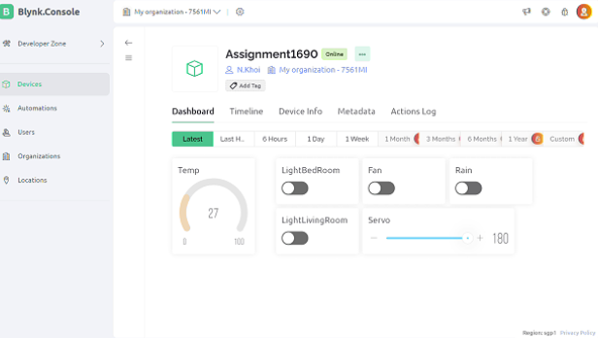

Figure 1. Blynk when all is off

Window

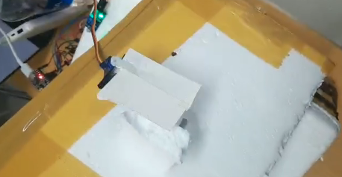

Figure 2. Window of cause there is rain

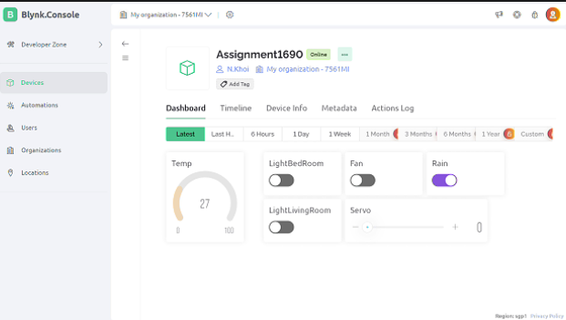

Figure 3. Blynk when there is Rain on and Servo off

LED Living room :

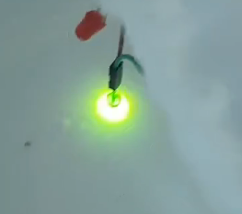

Figure 4. Light living room auto turn on when light sensor detect light

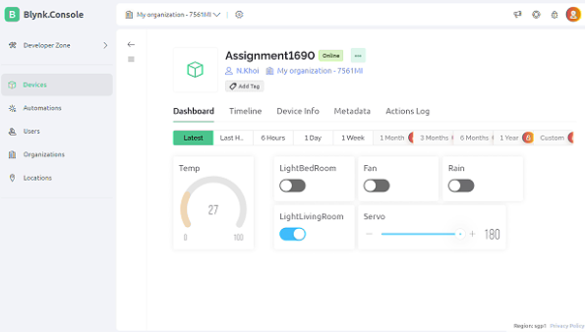

Figure 5. Blynk when living room light auto turn on

FAN:

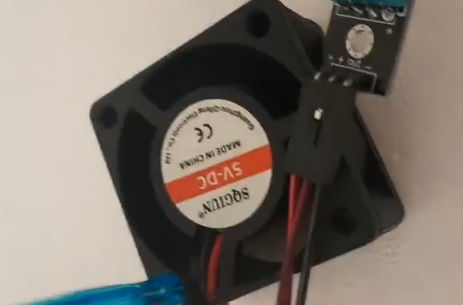

Figure 6. Fan turned on

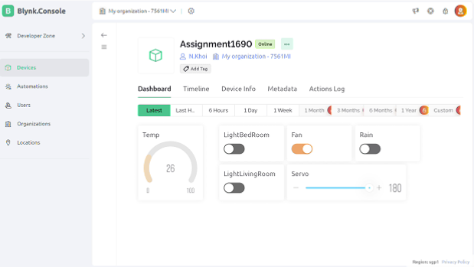

Figure 7. Turn on Fan from Blynk

LED Bed room:

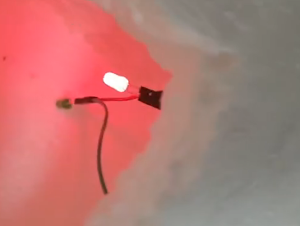

Figure 8. LED Bed room is turned on

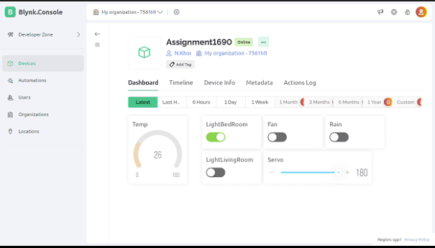

Figure 9. Turn on LED Bed room using Blynk

Source code:

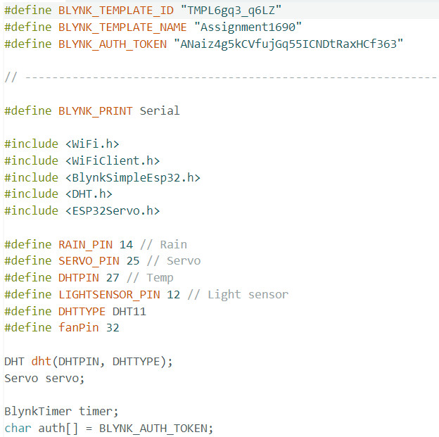

Figure 10. Connect to Blynk



Figure 11. Define serial interface as output and use library



Figure 12. Define the pin for sensors

|  |
| --- |
|  |

Figure 13. DHT, Servo Blynk installation, Blynk authentication token, and Wifi credentials

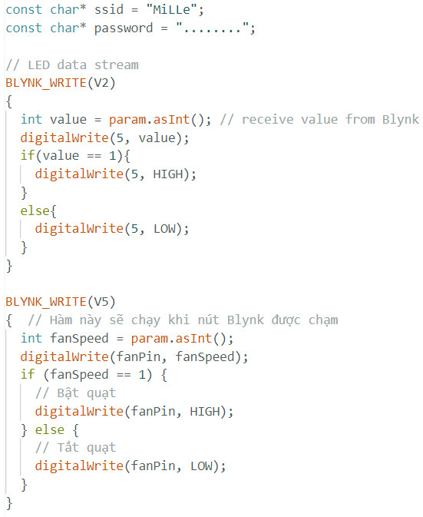

Figure 14. Control LED and control Fan through Blynk

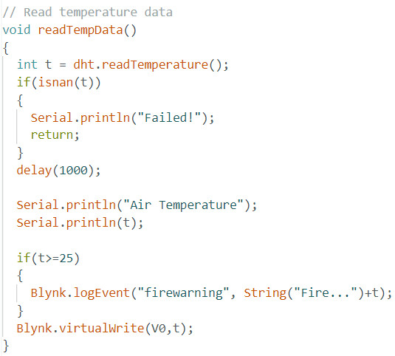

Figure 15. Read temperature data from DHT

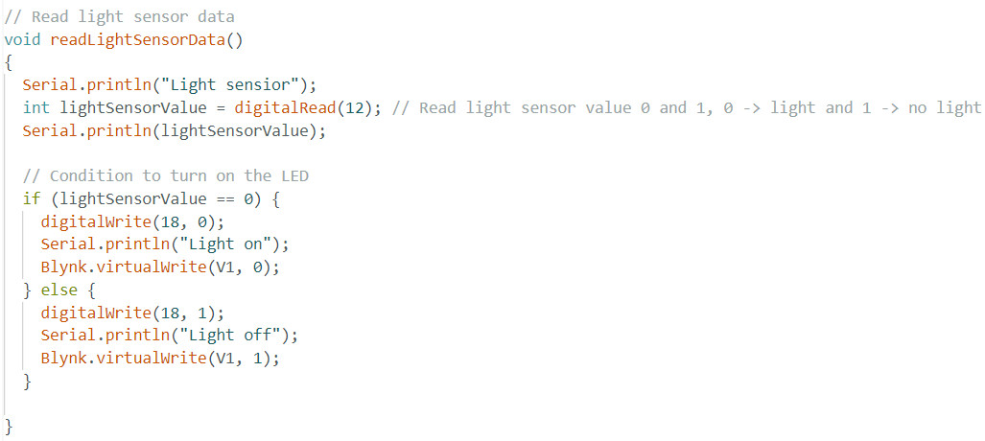

Figure 16. Read light sensor data and condition to turn on and off the LED living room

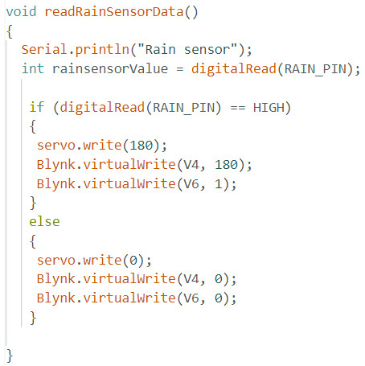

Figure 17. Read rain sensor data and condition to turn on and off the Servo

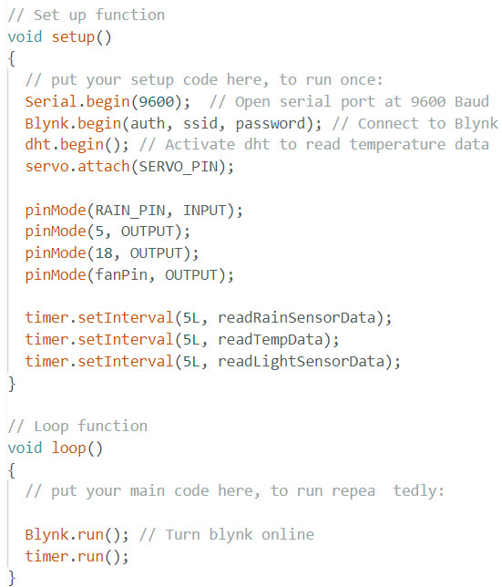

Figure 18. Set up and Loop function

Drive:

https://drive.google.com/file/d/18vaOnFEHOvCR3zPjeNKFrVqM2Xa-pM2K/view?usp=drive_link

# Task 2 – Test and evaluate the user feedback

The way my IoT meet the requirement:

To meet the IoT system requirements in the given scenario, the system incorporates two manual functions for controlling the LED and fan via Blynk. Additionally, two automated features enhance user convenience: automatic window activation during rain and intelligent LED control based on ambient light levels. The system also sends real-time data to Blynk, including room temperature for climate monitoring and rain status updates. This comprehensive design not only addresses user-initiated actions but also introduces intelligent automation and continuous data reporting, creating a cohesive and responsive IoT ecosystem that optimizes comfort, energy efficiency, and environmental awareness within the living space.

Feasibility ( including technical ), Economy and Organization feasibility.

Evaluating the proposed IoT system involves a thorough assessment of its technical, economic, and organizational aspects. The system's technical viability depends on the reliability of hardware components like the ESP32 microcontroller, DHT sensor, and servo motor, necessitating robust communication protocols for seamless integration with the Blynk platform. Economic feasibility centres on cost-effectiveness, considering expenses for hardware, maintenance, and potential energy savings. An essential cost-benefit analysis weighs upfront investment against long-term advantages. Organizational feasibility requires effective collaboration among stakeholders, including hardware engineers, software developers, and end-users, with user training crucial for smooth adoption. In summary, a comprehensive evaluation of technical, economic, and organizational feasibility is vital for assessing the potential success of the proposed IoT system.

Possibility of commercialization for your IoT application.

In term of commercialization for my IoT application, the system application IoT has low possibility that can be sold. And the reason is the devices integral to the system are themselves expensive, making the overall solution less accessible for potential buyer. the system is still in Lab for research purpose. Furthermore, the simplicity of the system, while advantageous in some respects, also renders it susceptible to replication.

Ability to improve.

In order to improve the system, I will add some more function like automated detect the thieve base on the sound, detect gas for fire alarm and door using lock password to improve the house. But the most importance change will be I will develop an app for my own IoT system with Flutter using Dart language, and improve my devices overall by buying more devices with higher quality and price.

# References

Byjus, 2023. *Byjus.* [Online]   
Available at: https://byjus.com/physics/light-emitting-diode/  
[Accessed December 2023].

FLM_Greenwich, 2023. *FLM Greenwich.* [Online]   
Available at: https://flm.greenwich.edu.vn/gui/role/student/SyllabusDetails?sylID=2668  
[Accessed December 2023].

Howard_Eglowstein, 2023. *Science Buddies.* [Online]   
Available at: https://www.sciencebuddies.org/science-fair-projects/references/introduction-to-servo-motors#:~:text=Positional%20rotation%20servo%3A%20This%20is%20the%20most%20common,beyond%20these%20limits%20to%20protect%20the%20rotational%20sensor.  
[Accessed December 2023].

RandomNerdTutorials, 2023. *Random Nerd Tutorials.* [Online]   
Available at: https://randomnerdtutorials.com/getting-started-with-esp32/  
[Accessed December 2023].

Robotique_Tech, 2021. *Robotique_Tech.* [Online]   
Available at: https://www.robotique.tech/robotics/control-a-fan-using-the-esp32-card/  
[Accessed December 2023].